**BUAN 6346 Big Data Analytics**

(Sqoop)

1. **Import the first name, last name, account number, city and state of the accounts who have exactly 1 device and store them in a directory named as your /NET-ID/loudacre/pset1.**
2. i) code

sqoop import -P \

--connect jdbc:mysql://localhost/loudacre \

--username training \

--target-dir /rxn162030/loudacre/pset1 \

--split-by acct_num \

--query 'select first_name, last_name, acct_num, city, state from accounts, accountdevice WHERE $CONDITIONS AND accounts.acct_num = accountdevice.account_id group by first_name, last_name, acct_num, city, state having count(*) = 1 order by acct_num asc' \

--m 1

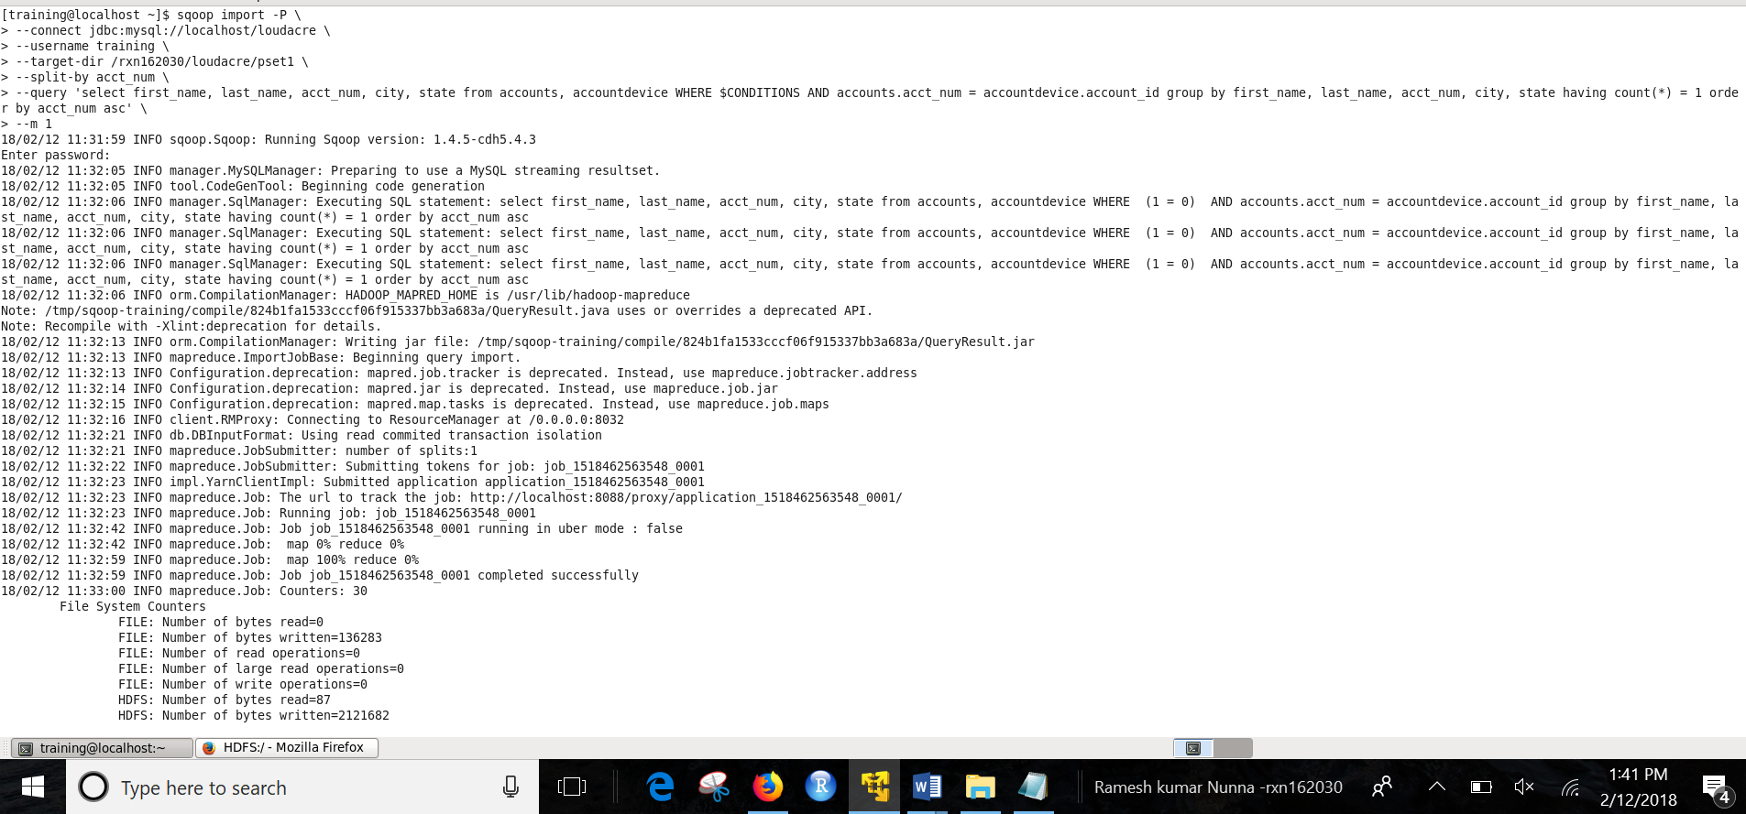

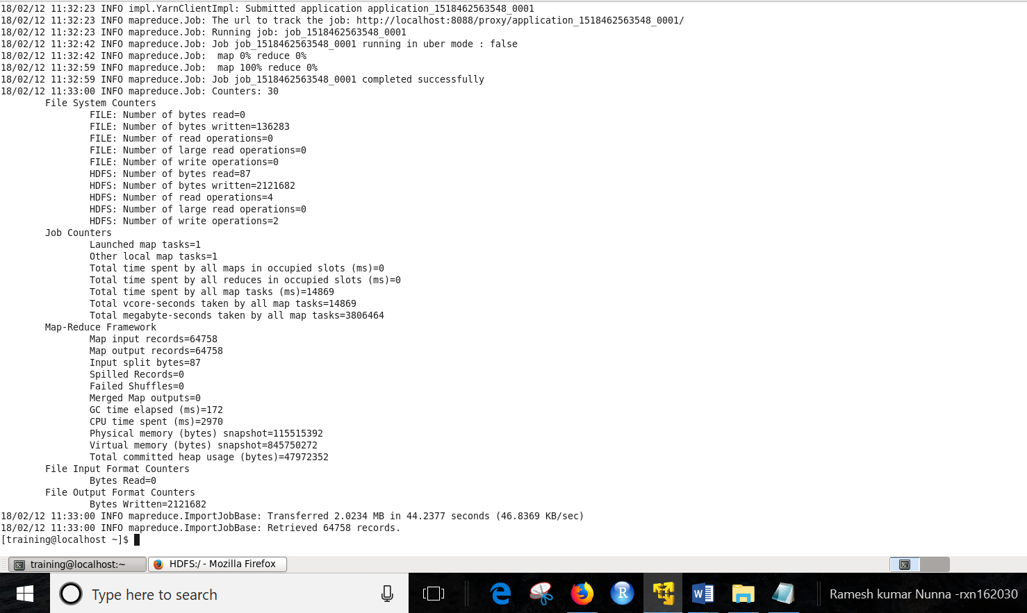

*ii) Verification*

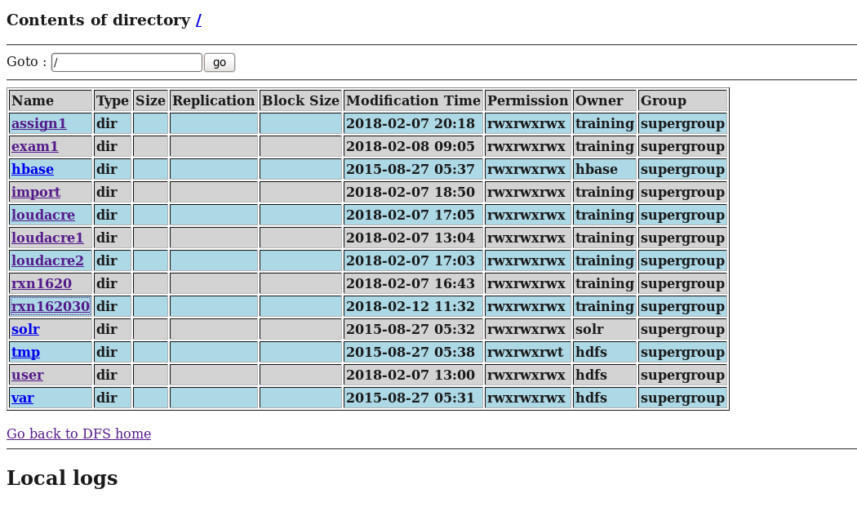

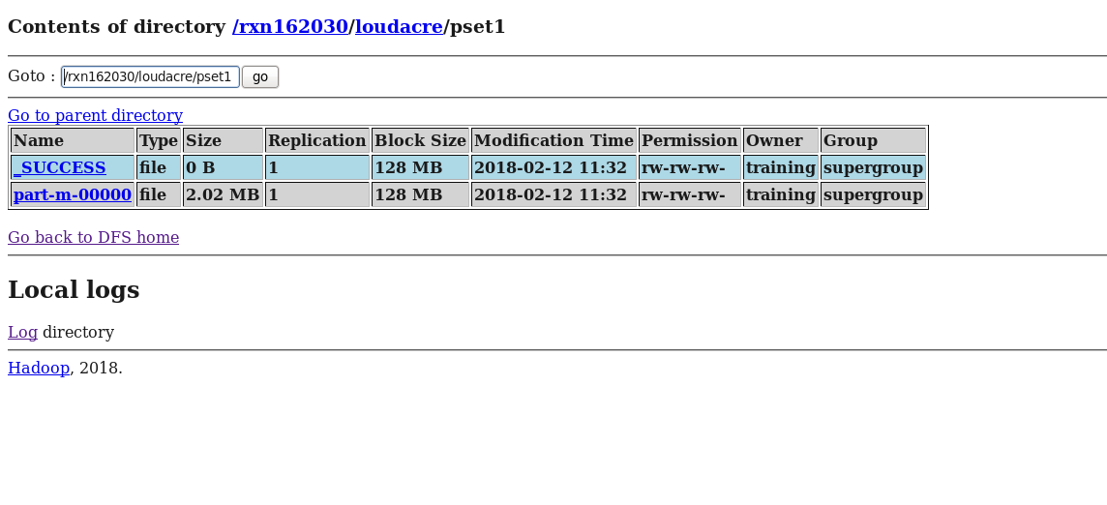

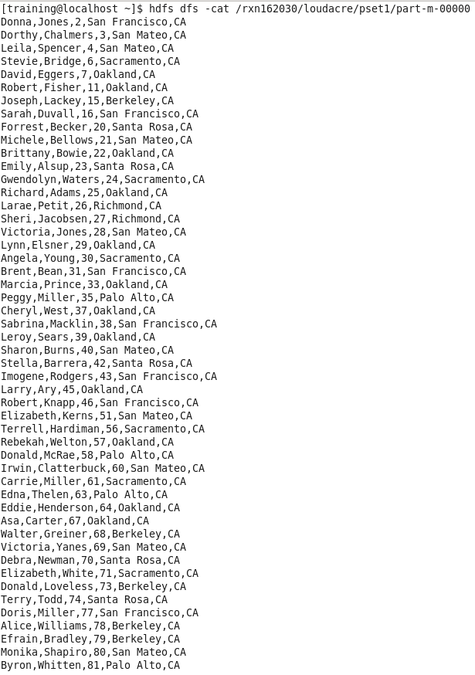

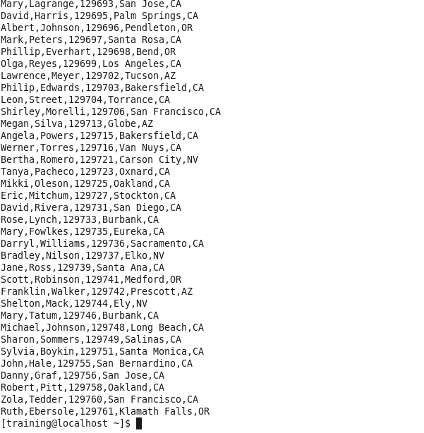

1. **Import the first name, last name, account number, city and state of the accounts who have exactly 2 devices and store them in a directory named as your /NET-ID/loudacre/pset2.**
2. i) code

sqoop import -P \

--connect jdbc:mysql://localhost/loudacre \

--username training \

--target-dir /rxn162030/loudacre/pset2 \

--split-by acct_num \

--query 'select first_name, last_name, acct_num, city, state from accounts, accountdevice WHERE $CONDITIONS AND accounts.acct_num = accountdevice.account_id group by first_name, last_name, acct_num, city, state having count(*) = 2 order by acct_num asc' \

--m 1

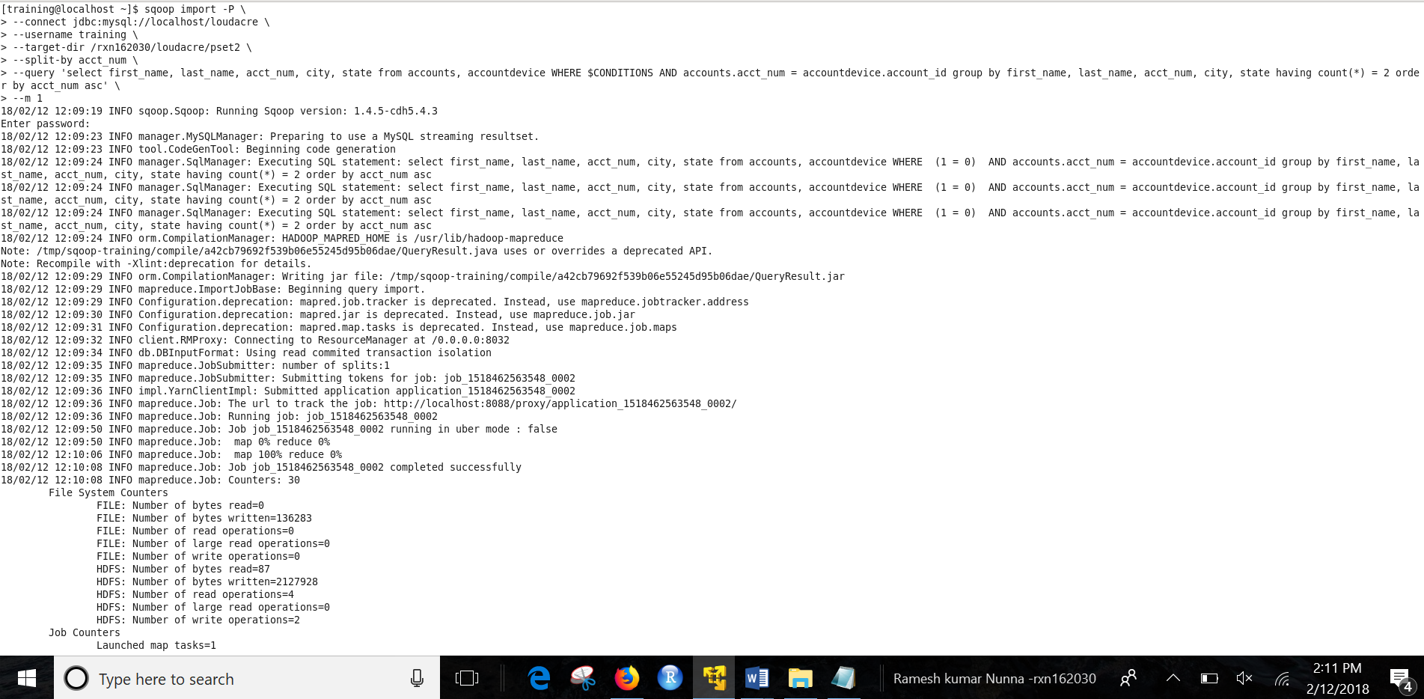

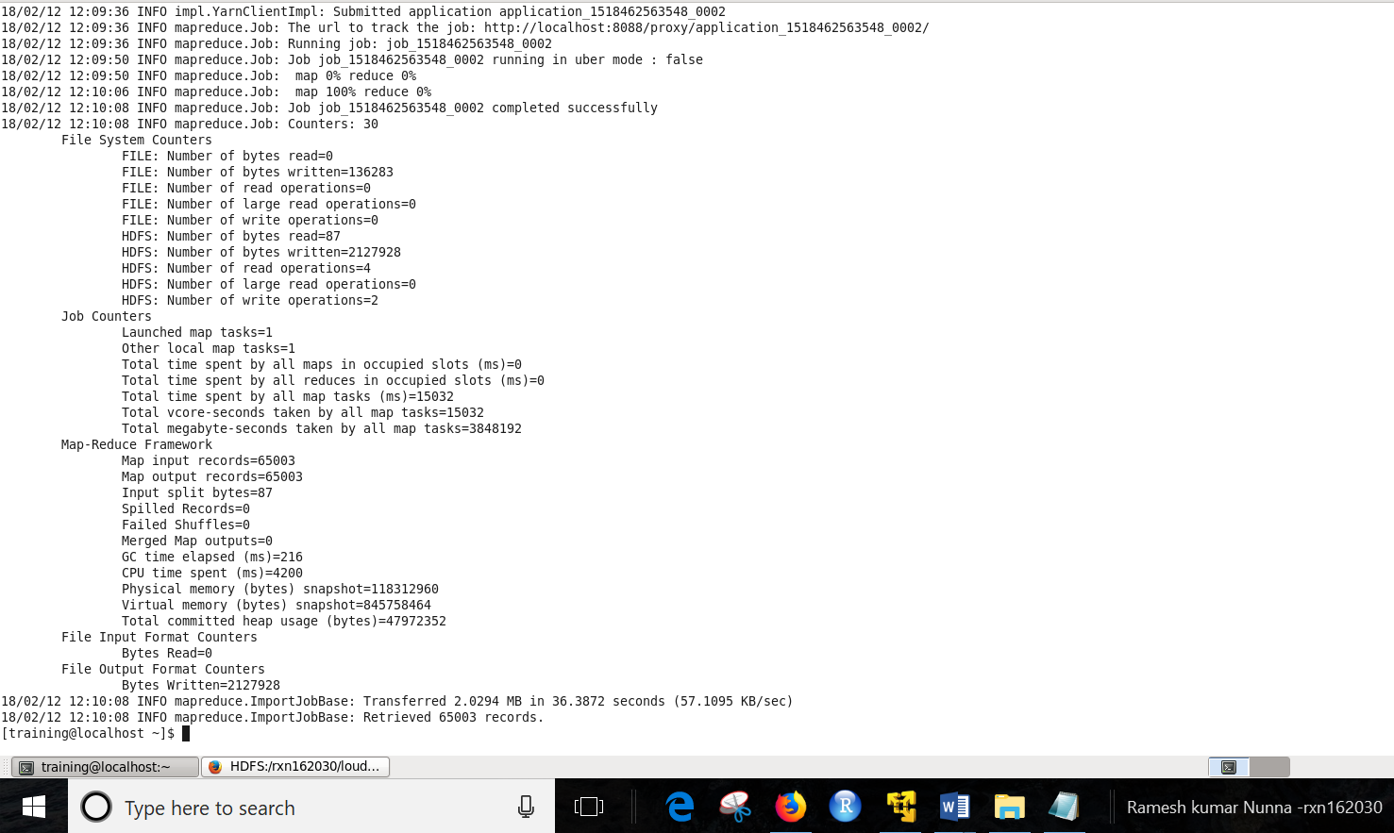

*ii) Verification*

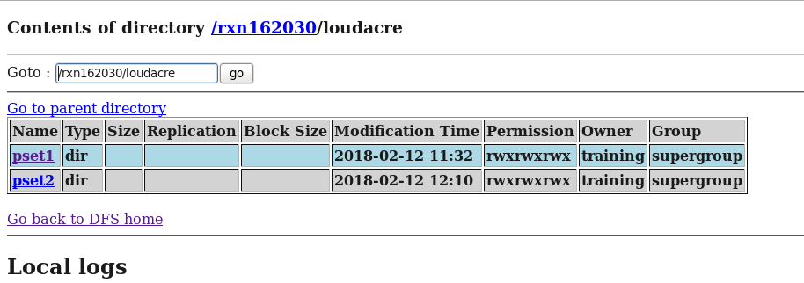

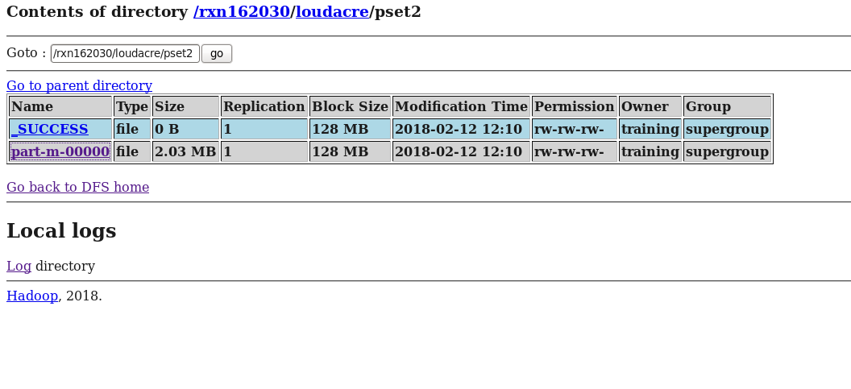

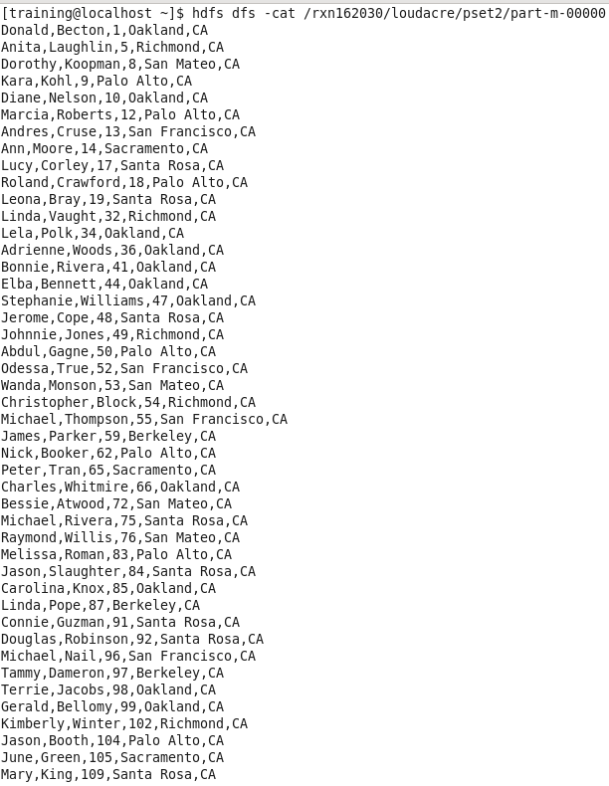

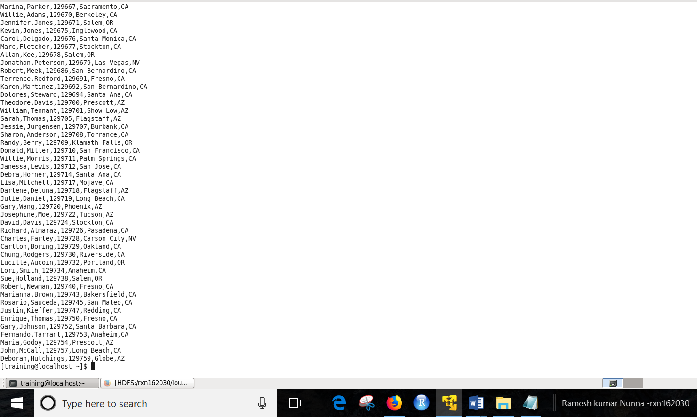

1. **Merge the two tables obtained from 1 and 2 and store them into a new directory named as your /NET-ID/loudacre/psetmain**
2. i) code

sqoop merge --new-data /rxn162030/loudacre/pset2/part-m-00000 --onto /rxn162030/loudacre/pset1/part-m-00000 --target-dir /rxn162030/loudacre/psetmain \

--jar-file /tmp/sqoop-training/compile/824b1fa1533cccf06f915337bb3a683a/QueryResult.jar --class-name QueryResult --merge-key acct_num

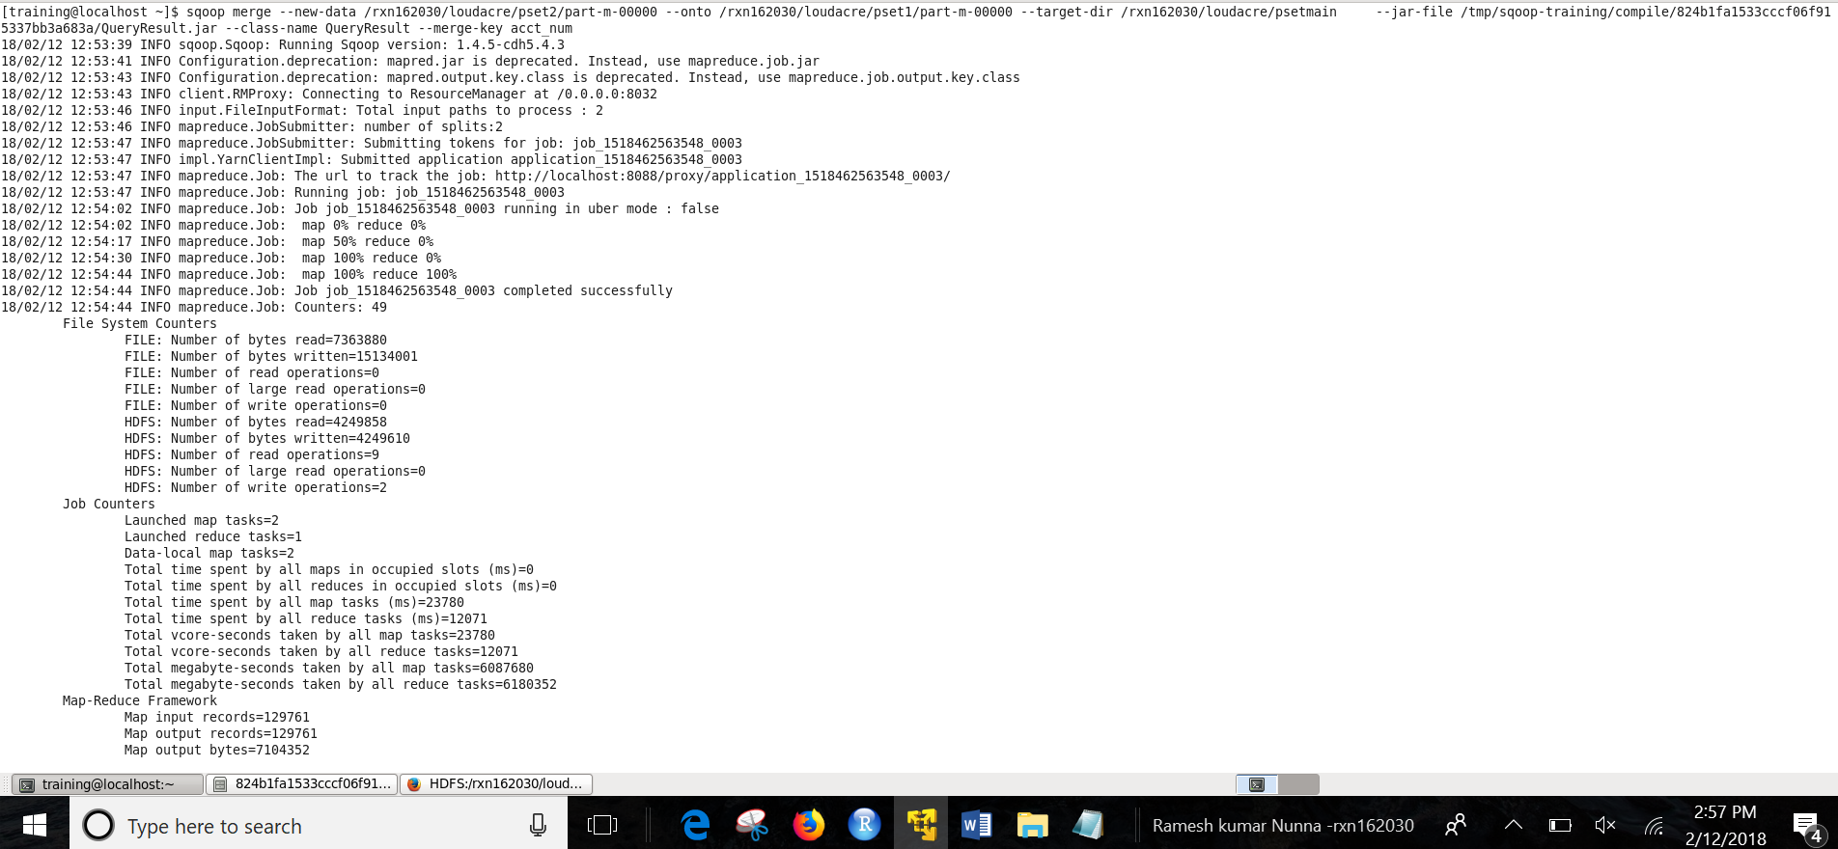

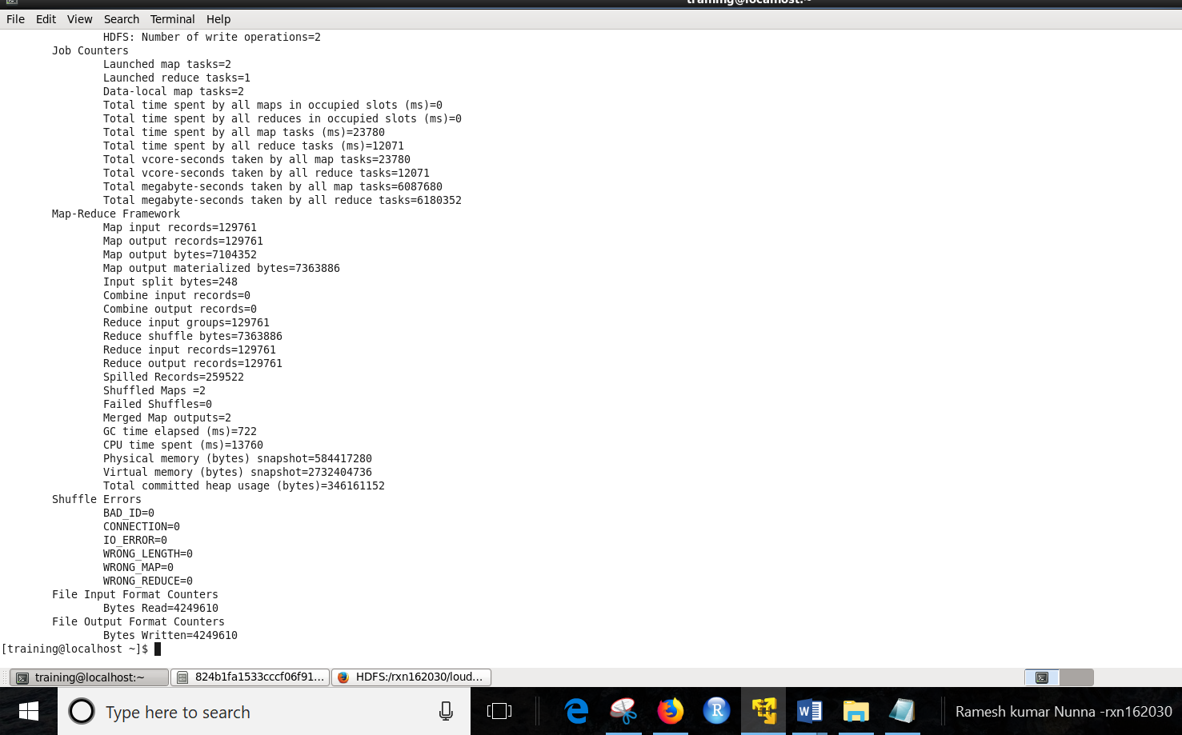

*ii) Verification*

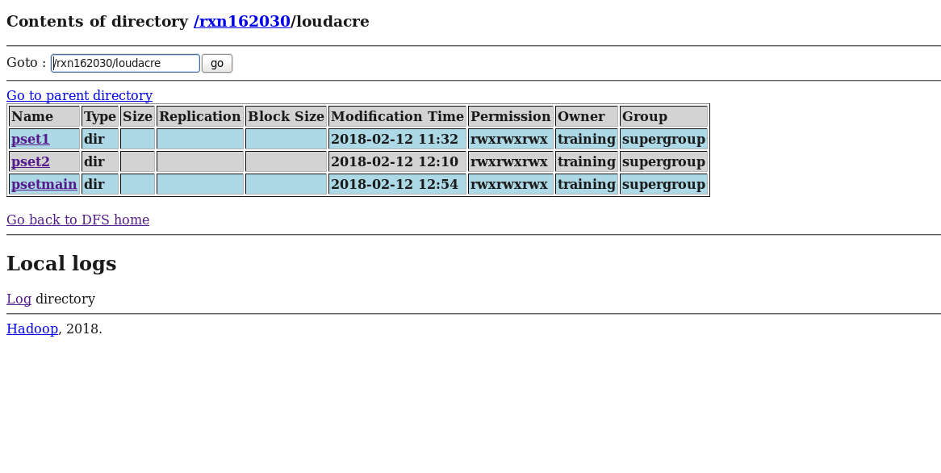

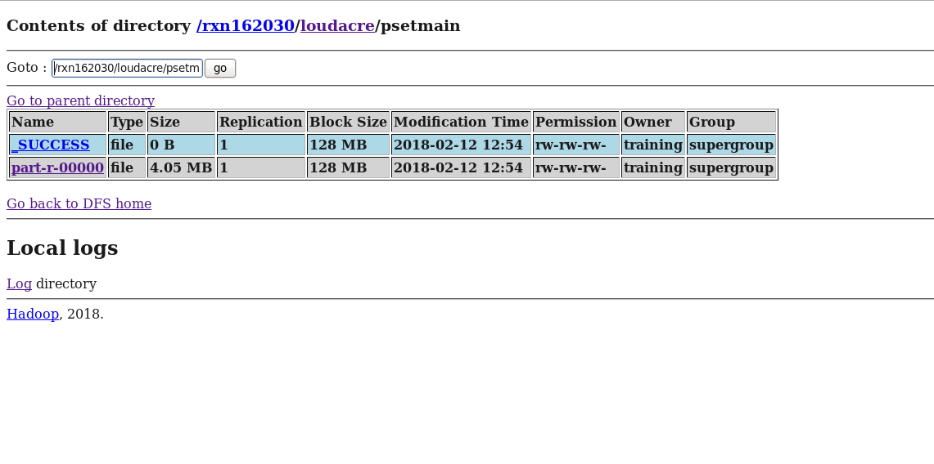

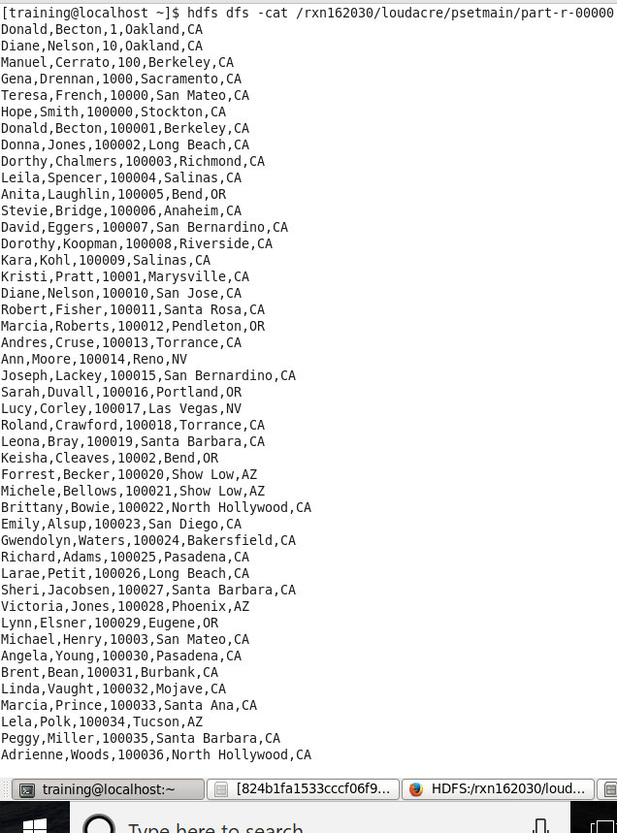

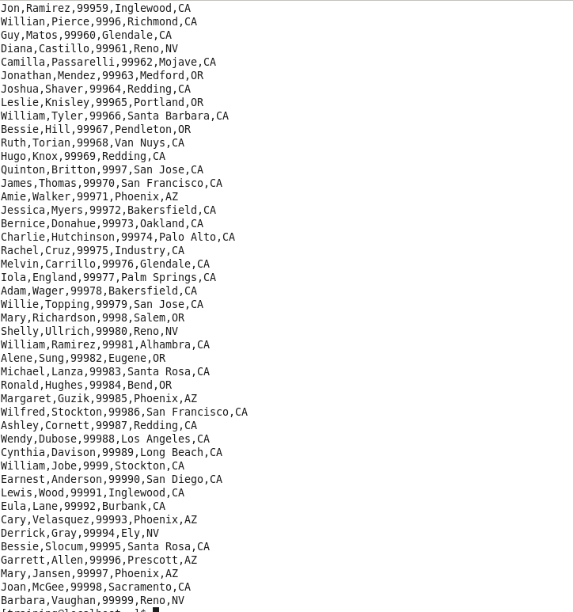



1. **Export the result of step 3 to a table named MergedAccts in MySQL.**

**a)** *i) code*

CREATE TABLE MergedAccts(

first_name VARCHAR(255),

last_name VARCHAR(255),

acct_num int(11),

city VARCHAR(255),

state VARCHAR(255));

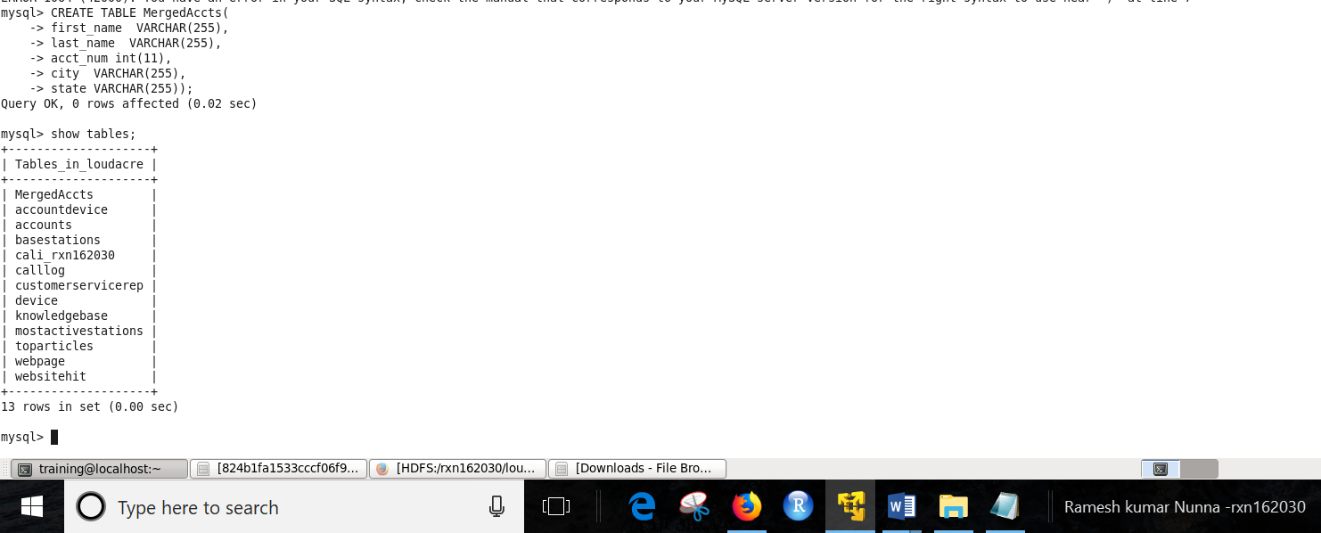

*ii) Exporting to MergedAccts table in mysql*

sqoop export \

--connect jdbc:mysql://localhost/loudacre \

--username training \

--password training \

--table MergedAccts \

--export-dir /rxn162030/loudacre/psetmain \

--batch

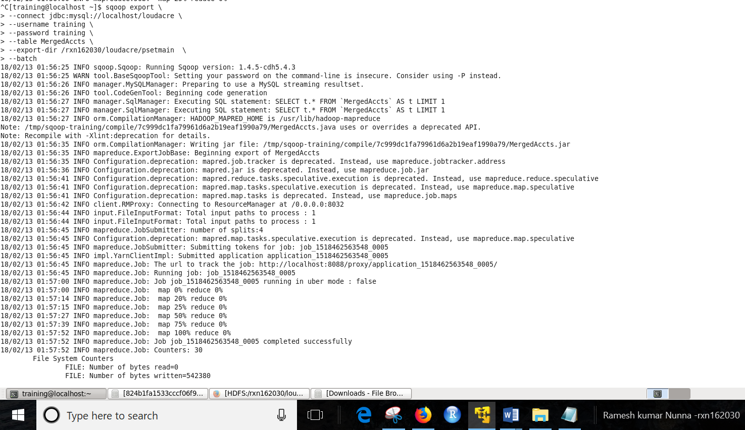

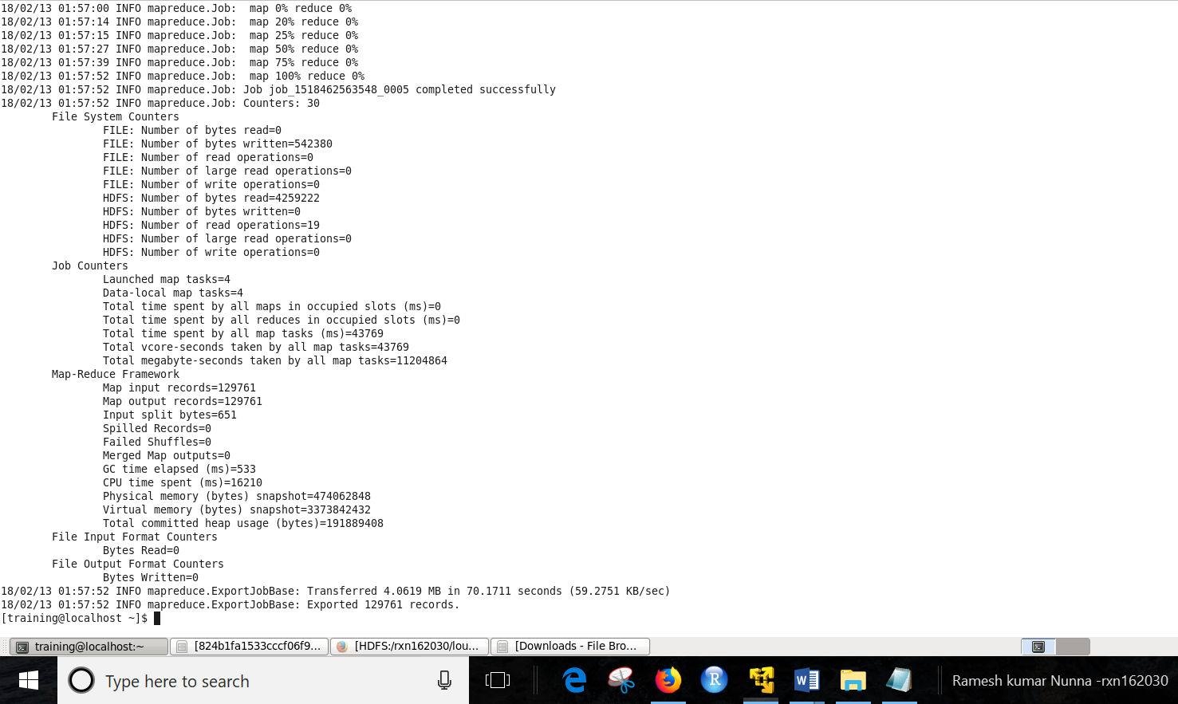

iii) verification

